Name: Wang Zihao

Student number: A0204706M

Week 5 Studio 2

Group 4b

13th February 2020

Question 1:

Question 2:

Period: 2.04ms

High-Time: 0.2ms

Low-Time: 1.84ms

Duty-Cycle: $\frac{200×{10}^{-6}}{2.04×{10}^{-3}}×100\%$ = 9.80 (3s.f.)

Question 3:

Duty-Cycle: D = $\frac{OCR0A}{255}×100$ = $\frac{25}{255}×100$ = 9.80 (3s.f.)

Question 4:

This is because we only need to generate the waveform and do not need to set a new OCR0A value after the current waveform, so no interrupt is needed, thus we need to do nothing in the ISR.

We change TCCR0A value from 0b10000001 to 0b11000001 to generate a complement of the current waveform. In order to generate the complement, we set OCOM0A to 11 and WGM to 01.

Question 7:



We increase OCR0A value gradually till 255 to introduce a fade in effect for LED, then decrease OCR0A value gradually till 0 to introduce a fade out effect for LED. We declare a static volatile int change = 1.

Question 8:

We change TCCR0B value from 0b00000011 to 0b00000101 to slow down the fading effect. It is to set clock source to clk/1024 instead of clk/64.

According to the formula, the frequency of the PWM decreases.

Question 9:

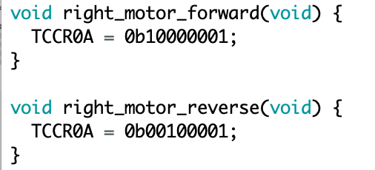

For right_motor_forward(), it sets OCOM0A to 10 and OCOM0B to 00, which disconnects OC0B and clears OC0A on Compare Match when up-counting and sets OC0A on Compare Match when down-counting. Moreover, it sets WGM to 01 to enable Phase Correct PWM Mode 1.

For right_motor_reverse(), it sets OCOM0A to 00 and OCOM0B to 10, which disconnects OC0A and clears OC0B on Compare Match when up-counting and sets OC0B on Compare Match when down-counting. Moreover, it sets WGM to 01 to enable Phase Correct PWM Mode 1.

We use two different counter to introduce two different PWM waveform as output, and every time we just activate one of the counter for one PWM waveform.